**Rise Together: A Crowdfunding Platform**

**Assistant Professor Mrs. Kavyashree J**

**Bhavana S K, Madhu S, N Deepak, Santhosh P**

*Department of Computer Science and Engineering*

*Rajiv Gandhi Institute of Technology*

*Bangalore-560032, Karnataka*

-----------------------------------------------------------------------------------------------------------------------------------------------

**Abstract -** The project titled “Rise Together: A Crowdfunding platform” introduces a groundbreaking Crowdfunding Platform on the Ethereum blockchain, revolutionizing traditional fundraising models. Leveraging smart contracts for seamless automation and execution of campaigns, the platform ensures transparency, security, and efficiency. Ethereum's decentralization eliminates intermediaries, reducing costs, and enhancing accessibility. Key features include a user-friendly interface, contribution tracking, and real time campaign monitoring. Utilizing Ether as the native cryptocurrency streamlines contributions, offering a secure and standardized means of support. Positioned at the intersection of blockchain and fundraising, this project contributes to the evolution of decentralized finance, showcasing Ethereum's potential for secure, inclusive, and innovative crowdfunding.

***Key Words*:** Rise Together, Crowdfunding, Blockchain, Smart Contract, Transparency, Decentralization, Wallet Integration.

# 1. INTRODUCTION

## Blockchain Overview

Blockchain is a decentralized and distributed ledger technology that securely records transactions across a network of computers. It relies on a chain of blocks, where each block contains a cryptographic hash of the previous one, ensuring data integrity. The decentralized network of nodes reaches consensus on transaction validity through mechanisms like Proof of Work or Proof of Stake. Cryptographic hash functions and immutability make the recorded data resistant to tampering. Smart contracts, self-executing code, automate and enforce predefined contract terms. Transactions are transparent, visible to all participants, while participant identities remain pseudonymous. Blockchain applications extend beyond finance to supply chain, healthcare, and voting systems. Its security, transparency, and resistance to censorship contribute to its widespread interest and adoption.

## Key elements of a blockchain

* Distributed ledger technology

All network participants have access to the distributed ledger and its immutable record of transactions. With this shared ledger, transactions are recorded only once, eliminating the duplication of effort that’s typical of traditional business networks.

* Immutable records

No participant can change or tamper with a transaction after it’s been recorded to the shared ledger. If a transaction record includes an error, a new transaction must be added to reverse the error, and both transactions are then visible.

* Smart contracts

To speed transactions, a set of rules called a smart contract is stored on the blockchain and executed automatically. A smart contract can define conditions for corporate bond transfers, include terms for travel insurance to be paid and much more.

## How blockchain works

* As each transaction occurs, it is recorded as a block of data.
* Each block is connected to the ones before and after it.
* Transactions are blocked together in an irreversible chain: a blockchain.

## ABOUT THE PROJECT

Blockchain crowdfunding platforms provide many ways for startups to raise money to create their own digital currencies. It is a peer-to-peer financial model, some of the most famous cryptocurrencies are Bitcoin, Ethereum, etc. customer. If anyone creates a new cryptocurrency (like Ethereum), anyone can join this fundraiser and contribute as much as they want. Ethereum blockchain provides the basis for crowdfunding decentralized applications. Ethereum is a decentralized blockchain that can be designed to work in a variety of applications thanks to its many features. Ethereum is programmable due to its diversity and functionality. It is important to understand Ethereum before you start using distributed applications. We will use the open source, decentralized Ethereum platform (Decentralized Applications) to build and use decentralized applications. Solidity is an Ethereum programming language that allows us to create smart contracts that run automatically when certain events occur. Learning Ethereum is necessary to create user-friendly implementations of the integrity of the system. Ethereum's decentralized structure, DAO support, and smart contracts make it an excellent platform for creating crowdsourced websites that can operate independently without intermediaries. The main aim of the proposed project is to solve the gap in the crowd by making the business safe, eliminating middlemen/agencies and ensuring transparent budget of the platform.

# 2. Body of Paper

Ethereum-based crowdfunding decentralized app uses smart contracts to organize crowdfunding fundraising. These smart contracts automatically transfer money to project developers Section is subject to the rules and conditions listed previously. Use intermediaries such as banks or other financial institutions Thanks to this approach, there is no longer a need for organizations. Decentralized autonomous organization (DAO) is an entity managed by smart contracts and completes itself as a smart contract. The code is also supported by Ethereum. DAO can be used to manage revenue was created and distributed through crowdfunding, eliminating the need for a middleman. Ethereum (ETH), a cryptocurrency and virtual Ethereum used to fund online transactions Machines (EVMs) that execute smart contracts are two unique features of Ethereum. Ethereum is great because of its decentralized structure and smart contracts A platform for building crowdsourced applications.

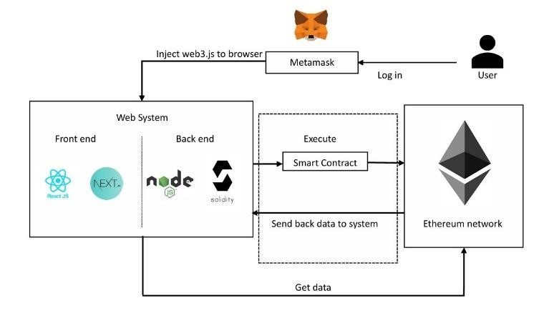

**Fig-1**: System Architecture

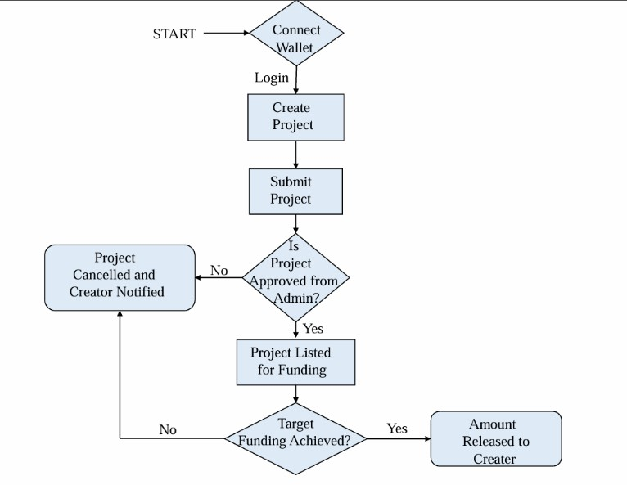

**Fig-2**: Data Flow

This system empowers users to bring their ideas to life by creating and potentially securing funding for projects through cryptocurrency. The journey begins by connecting a crypto wallet, acting as a source for both project initiation fees and future project payouts. Once connected, users can craft their project, outlining its details and objectives. After submission, a project admin assesses it for approval. If it receives the green light, the project goes live for public funding. This opens the door for interested supporters to explore projects and contribute cryptocurrency to help reach the targeted amount. Upon successful fundraising, the platform releases the funds to the project creator. In essence, this flowchart serves as a roadmap, guiding you through the process of launching your project fuelled by cryptocurrency on this platform.

**Fig-3**: Sequence Diagram

This platform fosters project creation and potential funding

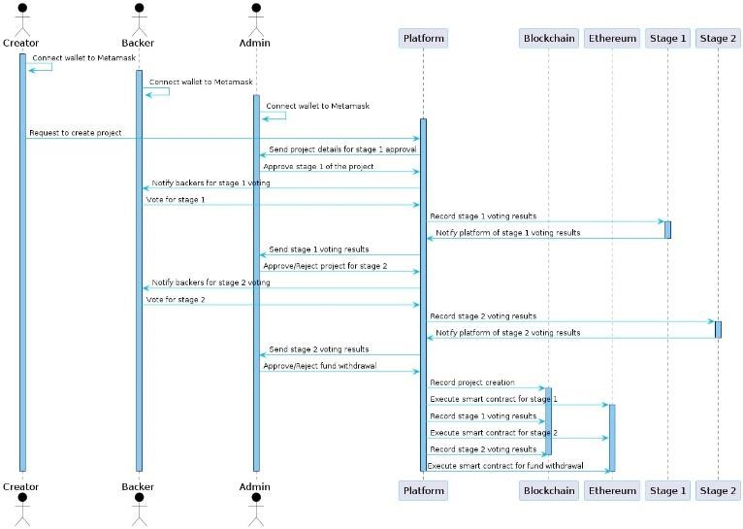

through cryptocurrency. First, creators link their crypto wallets, used for both project fees and receiving raised funds. They then submit their project proposal, including details and goals. An admin reviews it for adherence to platform guidelines. If approved, the project enters Stage 1, where backers are notified to vote. Based on the vote and the admin's decision, the project advances to Stage 2 (if applicable) with potentially more details or funding required. This stage mirrors Stage 1 with admin review, backer voting, and final approval. Finally, upon successful completion of both stages, the platform releases the funds to the project creator. This flowchart essentially navigates you through launching your cryptocurrency-driven project on this platform.

**Fig-4**: Class Diagram

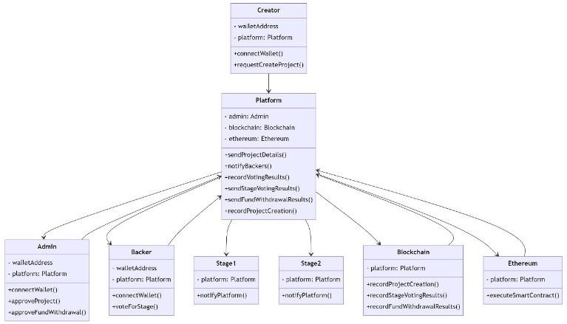

## 3. RELATED WORK

This paper explores the emergence of blockchain-based crowdfunding platforms and their potential to transform traditional fundraising models. We begin by reviewing relevant academic literature and ongoing projects to identify the advantages and challenges of this innovative approach.

## TECHNOLOGIES USED

**Web3** is a broad term encompassing the technologies behind decentralized applications (Dapps). It refers to the concept of a new, more open web built on blockchains, where data and applications are distributed and user-owned.

**Solidity** is a programming language specifically designed for writing smart contracts. Smart contracts are self-executing contracts with predefined terms stored on a blockchain. Solidity allows developers to create secure and transparent applications that run on blockchains like Ethereum.

**Next.js** is a React framework that simplifies building server side rendered and statically generated web applications. In the context of dApps, Next.js provides a robust foundation for creating user-friendly interfaces that interact with smart contracts deployed on a blockchain.

**Here's a breakdown of how these technologies collaborate: Solidity Smart Contract:** Developers write the logic for the dApp using Solidity. This logic defines the rules and functionalities of the application, such as user authentication, data storage, and transaction processing.

**Deployment:** The smart contract is then compiled and deployed onto a blockchain network, like Ethereum. Once deployed, the contract becomes immutable and transparent, meaning anyone can view its code and verify its execution.

**Next.js Frontend:** The user interface of the dApp is built using Next.js. This involves creating components that interact with the deployed smart contract. Tools like web3.js are often used to facilitate this communication between the frontend and the blockchain.

**User Interaction:** Users interact with the dApp through the Next.js interface. They can trigger functions defined within the smart contract, such as sending and receiving cryptocurrency, voting on proposals, or managing digital assets.

Benefits of using this Tech Stack:

**Decentralization:** By leveraging blockchain technology, dApps built with Web3, Solidity, and Next.js are censorship resistant and operate without a central authority. Security: Smart contracts are tamper-proof and transparent, ensuring secure and reliable execution of dApp functionalities. **Scalability:** Blockchain networks can handle a high volume of transactions, making dApps built on this stack suitable for largescale applications.

**User-friendly Interfaces:** Next.js provides a powerful framework for building user-friendly and interactive dApp interfaces.

## CURRENT RESEARCH LANDSCAPE

**Trust, Transparency, and Accessibility:** Examine how blockchain technology, through features like smart contracts and consensus mechanisms, can foster trust, transparency, and accessibility within crowdfunding campaigns. This paves the way for further exploration of blockchain's ability to address limitations in current crowdsourcing methods. Decentralized Finance (DeFi) and Crowdfunding: Buterin (2017) delves into the integration of DeFi and crowdfunding. Their research highlights the evolving role of Ethereum Decentralized Applications (DApps) in fundraising and underscores the significance of smart contracts in automating processes and reducing reliance on intermediaries. **Smart Contract-Based Engine**: Emphasize the critical role of smart contracts in blockchain crowdfunding platforms. Their research demonstrates how these automated administrative processes manage competition policies, budgets, and facilitate more efficient and effective fundraising.

**Security and Transparency**: Cornerstones of Success: Zhang et al. (2020) investigate how blockchain technology's immutable data storage can minimize the risk of fraud and forgery, thereby bolstering stakeholder trust. Security and transparency are fundamental for blockchain crowdfunding platforms to thrive.

**User Experience**: A Critical Factor: Kim et al. (2021) shift the focus to user experience (UX) within blockchain crowdfunding platforms. Their research emphasizes the importance of features like user-friendly interface design, seamless wallet connectivity, and transparency to enhance usability and accessibility for all participants.

**Practical Application**: Examining real-world applications, such as the "Rising Together: Crowdfunding Platform," offers valuable insights into the practical utilization of blockchain crowdfunding. Additional case studies can further illuminate the diverse applications of these platforms.

## Future Considerations and Challenges

**Environmental Management:** Swan and Sundararajan (2022) highlight the need for ongoing research and innovation to address challenges faced by blockchain crowdfunding platforms. Compliance management, scalability, and robust security remain crucial areas of focus.

**Security Research and Best Practices:** Research focused on security best practices for blockchain crowdfunding platforms is essential to safeguard public funds. Investigate how blockchain crowdfunding is affecting traditional financial institutions and how they are adapting or integrating this technology.

## CORE MODULES

This detailed explanation shows the main structure of a powerful blockchain-based crowdfunding platform. Each mode plays an important role in improving the accuracy of the data used in the system. The preprocessing module serves as the basis for cleaning and processing the data to ensure the reliability of the analysis. Blockchain integration enhances this further by creating a secure and tamper-proof record of transactions. Smart contracts add another layer of trust by automatically distributing money according to a certain priority. Expanding international collaboration through special features can foster knowledge acquisition with a wide range of sponsors. Finally, the transparent spend module uses the power of blockchain to track income in real time, ensuring that spend information is accurate and verifiable. Essentially, each mode works together to create a data-driven and secure ecosystem that benefits everyone involved.

## PROJECT OUTCOME

The impact of Rise Together extends far beyond a mere fundraising platform. Since its inception, the platform has sparked a surge in crowdfunding campaigns, attracting a significant influx of cryptocurrency from a diverse array of global contributors. This democratization of fundraising not only empowers creators but also galvanizes supporters, fostering a sense of collective participation. What sets Rise Together apart is its intuitive user interface, which streamlines campaign creation and encourages involvement by accepting various cryptocurrencies. However, its true strength lies in its unwavering commitment to transparency and equity. Through a unique voting system, contributors actively shape the destiny of campaigns, ensuring that only the most deserving causes receive funding. Moreover, rigorous admin verification procedures instil further confidence, guaranteeing the legitimacy of each endeavour. As funds securely flow to approved campaigns, Rise

Together transcends geographical barriers, uniting disparate communities in pursuit of shared objectives. With a steadfast vision for global positive change, Rise Together serves as a potent catalyst for collective action and generosity, illuminating the path towards a brighter tomorrow.

# 4. CONCLUSION

In conclusion, "Rise Together" stands as a solution to the limitations of traditional crowdfunding through the transformative power of blockchain technology. Our platform prioritizes transparency and security for both investors and startups. By leveraging smart contracts, we empower investors with real-time control and assurance over their contributions. Furthermore, the immutable transaction history diminishes the potential for fraud. "Rise Together" aspires to not only be transparent but also a bastion against fraudulent activity, all while upholding the core principles of decentralization. We acknowledge there's room for improvement, and future iterations will focus on solidifying the security and dependability of our blockchain-powered crowdfunding platform. Through continuous development, "Rise Together" strives to redefine the crowdfunding landscape, fostering a more accountable, secure, and globally accessible ecosystem.

# 5. REFERENCES

1. Menon, Arjun and Kadam, Kaustubh and Kumar, Pranav and Shah, Subash Kumar, Decentralized Crowdfunding Using Blockchain (January 15, 2023). Available at SSRN: https://ssrn.com/abstract=4324640 or DOI:

10.2139/ssrn.4324640.

1. Zad, Saniya and Khan, Zishan and Warambhe, Tejas and Jadhav, Rushikesh and Alone, Vinod, Crowdfunding Using Blockchain Technology (December 31, 2022). Available at SSRN: https://ssrn.com/abstract=4330476 or [http://dx.DOI.org/10.2139/ssrn.4330476.](http://dx.doi.org/10.2139/ssrn.4330476)
2. Laxman Pandhare, Prof. Priyanka Shirbhate (2022). Review On Blockchain Technology. Ijraset Journal for Research in Applied Science and Engineering Technology. DOI Link: [https://DOI.org/10.22214/ijraset.2022.39833.](https://doi.org/10.22214/ijraset.2022.39833)
3. Ritvik Gupta, Mayank Yadav, Usha Dhankar.

Crowdfunding using Ethereum Blockchain. Ijraset Journal for Research in Applied Science and Engineering Technology (2022). DOI: 10.22214/ijraset.2022.43130.

1. Dhansri Sudhir Bawankule, Rushikesh Bharatrao Adhau, Shyamli Rajesh Deotale, Kiran Laxman Pandhare, Prof. Priyanka Shirbhate (2022). Review On Blockchain Technology. Ijraset Journal for Research in Applied Science and Engineering Technology. DOI Link: [https://DOI.org/10.22214/ijraset.2022.39833.](https://doi.org/10.22214/ijraset.2022.39833)
2. Ashari, Firmansyah. Smart Contract and Blockchain for Crowdfunding Platform. International Journal of Advanced Trends in Computer Science and Engineering (2020). 9. 3036-3041. 10.30534/ijatcse/2020/83932020.
3. Hassija, Vikas & Chamola, Vinay & Zeadally, Sherali. (2020). BitFund: A Blockchain- based Crowdfunding

Platform for Future Smart and Connected Nation.

Sustainable Cities and Society. 60. 102145.

10.1016/j.scs.2020.102145.

1. Dhiman, Tushar and gulyani, Vidit and Bhushan, Bharat, Application, Classification and System Requirements of Blockchain Technology (May 14, 2020). Proceedings of the International Conference on Innovative Computing & Communications (ICICC) 2020, Available atSSRN: https://ssrn.com/abstract=3600745 or [http://dx.DOI.org/10.2139/ssrn.3600745.](http://dx.doi.org/10.2139/ssrn.3600745)
2. Lilani, Siddharth & Modi, Jimit & Malani, Dhrumil & Soni, Fenil. (2019). Securing the Software Development Life Cycle (SDLC) with a Blockchain Oriented Development Approach.
3. Sarkar, Abhrajit, Crowd Funding in India: Issues & Challenges Available at Social Science Research Network

February 27, 2016.SSRN: https://ssrn.com/abstract=2739008 or [http://dx.DOI.org/10.2139/ssrn.2739008](http://dx.doi.org/10.2139/ssrn.2739008)